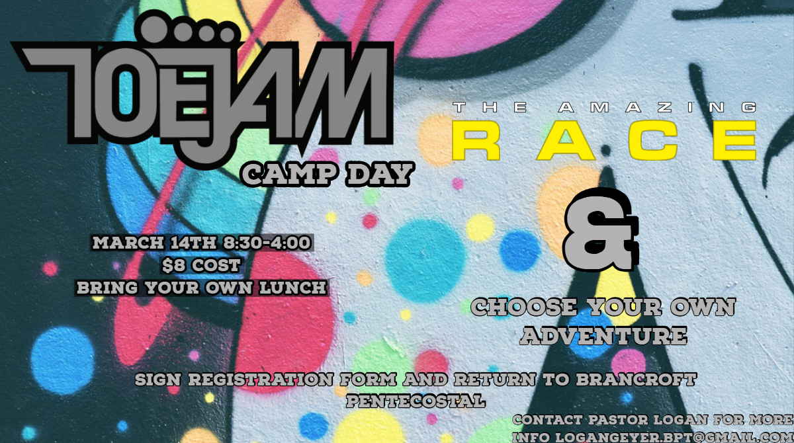
The Toejam Camp Day consists of two main events. In the morning youth will participate in a competition called the Amazing Race. Accompanied with trained leaders the youth will solve clues and challenges at the church and within the town of Bancroft. The youth will return to the church @ 12:00PM for lunch (Take note that youth must bring their own lunch). After lunch the youth will partake in the “Choose Your Own Adventure” portion of the camp day. Youth will get to sign up for two sessions where they can learn new skills, be competitive, and have fun. We have a guest Head chef, Archery tag, Henna tattoo, Baking class, and so much more. Pick up will be at 4:00pm. The sooner you sign up the better chance of getting a session you want
Name of Youth: Grade: Birth Date:
Parent’s Name: Phone Number:
Emergency Contact: Phone Number:
Parent or Person Picking up Youth:
Any Allergies and Medications the Lead team should be aware of:

Rank the sessions from 1(favourite) – 3(least favourite) For each list of three classes
List 1: Archery Tag Board Game Craft Cooking (From Scratch Pizzas)
List 2: Sword Making (Foam Swords)Henna Tattoos Baking and Decorating
I, give my child, to participate in Toejam’s Camp day on March 14th, 2019.

Signature Date

